* Download Python 3 installer → [www.python.org](http://www.python.org/)
* Run installer as administrator
* Choose custom installation
* 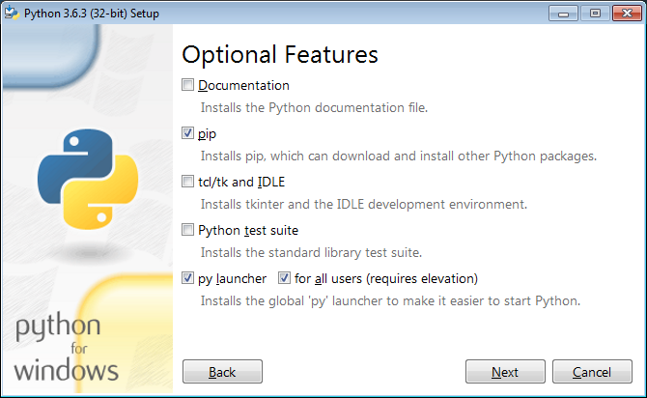
* customize installation path
* 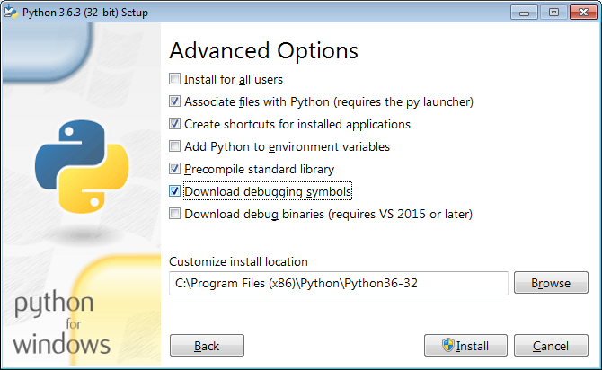
* Run Windows CMD as admin
* change Directory to C:\...\Python36-32\Scripts
* install matplotlib, numpy, scipy by typing
  + pip install numpy
  + pip install matplotlib
  + pip install scipy  
    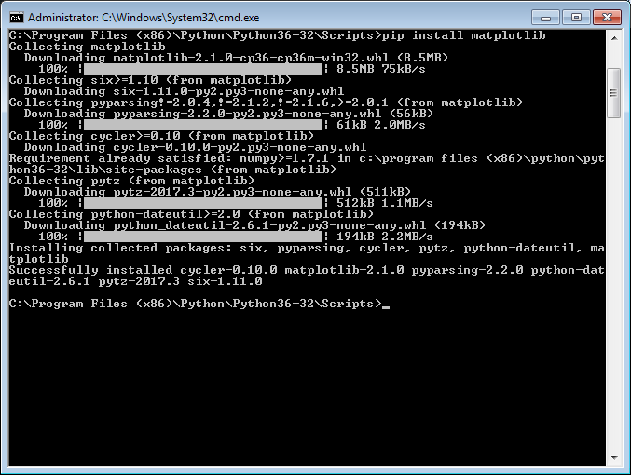
* Use dots instead of commas as decimal marker